BENCHMARKING INDUSTRY SPECIFIC CHURN RATES

(EMPLOYEE CHURN PREDICTION)

A Project Report

submitted in partial fulfillment of the requirements

of

TSP- AI ML FUNDAMENTALS

by

**U.MAHESWARI, au950821103033**

Under the Esteemed Guidance of

**Name of Guide**

**P.RAJA**

**ACKNOWLEDGEMENT**

We would like to express our deepest gratitude to all those who contributed to the completion of this project on bench marking industry-specific churn rates. First and fore most, we extend our sincere appreciation to our supervisor/advisor [Dr.K.Sumangala], for their invaluable guidance, encouragement, and unwavering support throughout the duration of this project. Their expertise and insights have been instrumental in shaping the direction and methodology of our research.

We are immensely thankful for their assistance in data collection, analysis, and interpretation. Their expertise and dedication have significantly enriched the quality of our findings and conclusions.

We would also like to acknowledge the contributions for their valuable input and feedback during the course of this project. Their constructive criticism and suggestions have played a crucial role in refining our methodology and enhancing the rigor of our analysis.

Additionally, we extend our gratitude to all the participants and organizations who generously shared their data and insights, without which this research would not have been possible.

#### ABSTRACT

Customer churn poses a significant challenge for businesses across various industries, impacting revenue, profitability, and long-term sustainability. Understanding industry-specific churn rates and factors driving customer attrition is paramount for organizations striving to enhance customer retention strategies. This study presents a thorough investigation into bench marking industry-specific churn rates through a comprehensive comparative analysis.

The research methodology encompasses data collection from diverse industries, including telecommunications, software as a service (SaaS), retail, and finance. Utilizing advanced statistical techniques and machine learning algorithms, we analyze extensive datasets to identify patterns, trends, and correlations related to churn behavior. By examining industry-specific benchmarks, we uncover insights into the factors influencing customer churn, such as pricing strategies, service quality, competitive landscape, and customer satisfaction levels.

Our findings reveal nuanced differences in churn rates across industries, highlighting the unique challenges and opportunities each sector faces in managing customer attrition. Moreover, we explore the effectiveness of various customer retention strategies employed by leading companies within each industry, ranging from personalized marketing initiatives to proactive customer support and loyalty programs.

Through a comparative lens, this study enables businesses to benchmark their churn rates against industry peers, facilitating strategic decision-making and performance improvement initiatives. Additionally, it offers actionable recommendations tailored to each industry, empowering organizations to develop targeted churn management strategies aimed at reducing attrition rates and enhancing overall customer satisfaction and loyalty.

By synthesizing insights from diverse sectors, this research contributes to the advancement of churn management practices and provides a roadmap for businesses to navigate the complex landscape of customer retention in today's competitive marketplace. Ultimately, the insights gleaned from this study serve as a valuable resource for organizations seeking to optimize their customer relationship management efforts and achieve sustainable growth in the face of evolving market dynamics.

**TABLE OF CONTENTS**

Abstract

**Chapter 1.**  **Introduction**

1.1 Problem Statement

1.2 Problem Definition

1.3 Expected Outcomes

1.4. Organization of the Report

**Chapter 2.**  **Literature Survey**

2.1 Paper-1

2.2 Brief Introduction of Paper

2.3 Techniques used in Paper……………………………………………………………………………

**Chapter 3.**  **Proposed Methodology**

3.1 System Design

3.1.1 Registration…

3.1.2 Recognition………………………………………………………………………………………………….

3.2 Modules Used……………………………………………………………………………………………….

3.3 Data Flow Diagram…………………………………………………………………………………………

3.4 Advantages……………………………………………………………………………………………………

3.5 Requirement Specification……………………………………………………………………………..

3.5.1 Hardware Requirements……………………………………………………………………………….

3.5.2Software Requirements………………………………………………………………………………….

**Chapter 4.**  **Implementation and Results**

**Chapter 5.**  **Conclusion**

**Github Link.....................................................................................................................**

**References** **…..**

**CHAPTER 1**

**INTRODUCTION**

In today's dynamic business landscape, understanding and effectively managing customer churn rates is essential for sustainable growth and competitiveness. Churn, the rate at which customers discontinue their relationship with a company over a specific period, directly impacts revenue and profitability. Therefore, benchmarking industry-specific churn rates serves as a crucial tool for organizations to assess their performance relative to competitors and identify opportunities for improvement.

This introduction sets the stage for a comprehensive exploration of the benchmarking process focused on industry-specific churn rates. It highlights the importance of churn rate benchmarking in guiding strategic decision-making and enhancing customer retention efforts within various sectors. Throughout this project, we delve into the methodologies, data sources, analysis frameworks, and actionable insights necessary to effectively benchmark and manage churn rates in alignment with industry standards and best practices.

1. **Problem Statement:**

Develop a Python-based solution to benchmark churn rates within a specific industry, aiming to provide actionable insights for improving customer retention strategies. The project involves collecting and preprocessing relevant data from various sources, including customer databases or CRM systems, ensuring data accuracy and consistency. Through industry-specific metrics and definitions, calculate churn rates and compare them across different segments or cohorts within the industry. Utilize visualization techniques to depict trends and outliers effectively, facilitating the identification of areas for improvement. Implement statistical tests or methodologies to validate findings and ensure scalability to handle large datasets efficiently. The solution should be well-documented, with clear instructions for usage and interpretation of results, and capable of adapting to evolving industry trends and new data inputs.

1. **Problem Definition:**

The problem at hand is to systematically benchmark industry-specific churn rates to gain insights into customer retention performance. This entails defining clear objectives, selecting appropriate metrics, identifying comparison groups, gathering and normalizing data, analyzing trends, drawing actionable insights, setting achievable goals, implementing targeted strategies, and continually monitoring and adjusting performance. By effectively benchmarking churn rates against industry peers, companies can identify strengths and weaknesses, pinpoint areas for improvement, and develop strategies to enhance customer retention and competitiveness within the market landscape.

1. **Expected Outcomes**:

1. *Comparison with Industry Standards:* By benchmarking churn rates against industry standards, companies can assess their performance relative to competitors or industry norms. This helps in understanding if the churn rates are within acceptable limits or if there's room for improvement.

2. *Identification of Outliers:* Benchmarking can help identify outliers - companies with unusually high or low churn rates compared to industry averages. This can prompt further investigation into the factors contributing to these deviations.

3. *Insights into Industry Dynamics:* Analyzing industry-specific churn rates provides insights into the unique dynamics, challenges, and trends within the industry. For example, industries with high demand for specialized skills may experience higher churn rates due to talent poaching.

4. *Informing Strategy and Decision-Making:* Understanding industry-specific churn rates can inform strategic decisions related to talent acquisition, retention efforts, compensation packages, and organizational culture. For instance, industries with high churn rates may need to focus more on employee engagement and retention strategies.

5. *Tailored Predictive Models:* Industry-specific benchmarks can guide the development of more accurate predictive models for employee churn. By incorporating industry-specific factors and trends, such models can better anticipate churn likelihood and help organizations take proactive measures to retain valuable talent.

6. *Competitive Advantage:* Companies that effectively benchmark industry-specific churn rates and leverage the insights gained can gain a competitive advantage by implementing targeted retention strategies, reducing turnover costs, and maintaining a more stable workforce.

Overall, benchmarking industry-specific churn rates in employee churn prediction enables organizations to gain valuable insights, make informed decisions, and ultimately improve their talent management practices.

1. **Organization of the Report:**

then organizing a report on benchmarking industry-specific churn rates, it's essential to structure it in a clear and logical manner to effectively communicate findings and insights. Here's a suggested outline for such a report:

1. *Introduction:*

- Provide an overview of the purpose of the report.

- Explain the significance of benchmarking industry-specific churn rates in employee churn prediction.

- Outline the structure of the report.

2. *Methodology:*

- Describe the methodology used for benchmarking industry-specific churn rates.

- Explain how data was collected, including sources and criteria for selection.

- Detail any statistical methods or tools employed for analysis.

3. *Industry Analysis:*

- Present an analysis of industry-specific churn rates for relevant sectors.

- Provide key statistics and trends, such as average churn rates, variations across industries, and factors influencing churn.

- Include comparative analysis with industry benchmarks and norms.

4. *Company-Specific Analysis:*

- Analyze the organization's churn rates in comparison to industry standards.

- Identify any significant deviations from industry averages and potential reasons behind them.

- Highlight areas of strength and areas for improvement within the organization.

5. *Factors Contributing to Churn:*

- Explore factors contributing to employee churn within the organization and the broader industry context.

- Consider both internal factors (e.g., organizational culture, compensation, career development) and external factors (e.g., market trends, industry competition).

6. *Predictive Modeling:*

- Discuss the development and validation of predictive models for employee churn.

- Explain how industry-specific benchmarks were incorporated into the modeling process.

- Present insights gained from the predictive models, including factors influencing churn prediction and potential interventions.

7. *Recommendations:*

- Based on the findings, provide actionable recommendations for the organization to improve employee retention.

- Tailor recommendations to address specific challenges and leverage opportunities identified through benchmarking.

- Prioritize recommendations based on their potential impact and feasibility of implementation.

By following this structured approach, the report can effectively communicate the results of benchmarking industry-specific churn rates and provide actionable insights for improving employee retention strategies within the organization.

**CHAPTER 2**

**LITERATURE SURVEY**

1. **Paper-1**

**Robust Real-Time Face Detection by Paul Viola and Michael A. Jones, 2003**

* 1. **Brief Introduction of Paper:**
  2. Robust Real-Time Object Detection" is a seminal paper by Paul Viola and Michael Jones, published in 2003. It introduced the Viola-Jones object detection framework, which revolutionized computer vision with its efficient and accurate method for detecting objects, particularly faces, in real-time. The algorithm employs a cascade of simple classifiers trained using AdaBoost, combined with integral image representations for rapid feature computation. This approach enabled robust detection even under various conditions such as varying lighting and occlusion, making it widely adopted in applications ranging from surveillance to photography.
  3. **Techniques used in Paper:** The robust real-time face detection technique introduced by Paul Viola and Michael Jones in 2003 primarily relies on three key techniques:

1. Haar-like features: The algorithm uses Haar-like features, which are simple rectangular features that capture local intensity variations in an image. These features are computationally efficient to compute and can effectively capture facial characteristics like edges, lines, and textures.

2. Integral image representation: To speed up the computation of Haar-like features, Viola and Jones introduced the integral image representation. This representation allows for the rapid calculation of the sum of pixel intensities within any rectangular region of an image, enabling fast feature evaluation.

3. Cascade of classifiers trained with AdaBoost: The Viola-Jones algorithm employs a cascade of classifiers trained using the AdaBoost (Adaptive Boosting) algorithm. AdaBoost iteratively selects a set of weak classifiers (simple classifiers that perform slightly better than random guessing) and combines them into a strong classifier. This process focuses computational resources on promising regions of an image while quickly discarding background regions that are unlikely to contain faces.

By combining these techniques, Viola and Jones achieved real-time face detection performance with high accuracy and robustness to variations in illumination, pose, and occlusion.

**CHAPTER 3**

**PROPOSED METHODOLOGY**

**\*Introduction\***

Employee churn, or turnover, is a critical metric for organizations across industries, directly impacting productivity, morale, and overall business performance. Understanding industry-specific churn rates is essential for organizations to assess their competitiveness, identify areas for improvement, and develop targeted retention strategies. In this section, we introduce the proposed methodology for benchmarking industry-specific churn rates, which forms the foundation for our analysis and insights.

*Purpose of the Methodology*

The primary objective of this methodology is to provide a structured approach for comparing and evaluating churn rates within specific industries. By establishing industry benchmarks and norms, organizations can gain valuable insights into their own churn performance and identify opportunities for optimization**.**

* 1. **System Design:**

Designing a system for benchmarking industry-specific churn rates using Python involves several steps, including data collection, processing**, a**nalysis, and visualization. Here's an outline of the system design along with Python program examples for each step:

1. *Data Collection:*

- Use Python libraries like requests or Beautiful Soup for web scraping industry reports and government databases.

- Access proprietary datasets using APIs or data connectors.

- Example:

python

import requests

# Web scraping example

response = requests.get('https://example.com/industry report')

if response.Status code == 200:

industry data = response.json() # Assuming response is JSON data

2. *Data Processing and Integration:*

- Utilize Python libraries like pandas for data cleaning, preprocessing, and integration.

- Standardize data formats and handle missing values.

- Example:

python

import pandas as pd

# Preprocessing example

df = pd.read_csv('industry_data.csv')

df_cleaned = df.dropna() # Remove rows with missing values

3. *Industry Segmentation:*

- Develop Python functions or scripts to classify industries based on predefined criteria.

- Implement machine learning models for automated industry classification.

python

# Industry segmentation example

def classify_industry(industry_data):

# Implement classification logic here

return industry_category

industry_category = classify_industry(industry_data)

4. *Churn Rate Calculation:*

- Write Python functions to calculate churn rates using appropriate formulas.

- Handle different time intervals (e.g., annually, quarterly).

- Example:

python

# Churn rate calculation example

def calculate_churn_rate(data, time_interval):

# Implement churn rate calculation logic here

return churn_rate

churn_rate = calculate_churn_rate(df_cleaned, 'annual')

5. *Benchmarking Analysis:* - Use Python libraries like numpy and scipy for statistical analysis.

- Visualize benchmarking results using matplotlib or seaborn.

- Example:

python

import numpy as np

import matplotlib.pyplot as plt

# Benchmarking analysis example

churn_rates = [0.1, 0.15, 0.08, 0.12, 0.09] # Example churn rates for different industries

mean_churn_rate = np.mean(churn_rates)

median_churn_rate = np.median(churn_rates)

plt.bar(range(len(churn_rates)), churn_rates)

plt.xlabel('Industry')

plt.ylabel('Churn Rate')

plt.title('Industry-Specific Churn Rates')

plt.show()6. *User Interface and Reporting:*

- Develop a web application using frameworks like Flask or Django for user interaction.

- Integrate visualization tools like Plotly or Dash for interactive reporting.

- Example:

python

from flask import Flask, render_template

app = Flask(__name__)

@app.route('/')

def index():

# Render HTML template with benchmarking results

return render_template('index.html', churn_rates=churn_rates)

if __name__ == '__main__':

app.run(debug=True)

* + 1. **Registration**:

To register for benchmarking industry-specific churn rates, you'll typically need to reach out to industry associations, market research firms, or specialized benchmarking organizations that offer this service. They often require you to sign up for their programs or services and may have fees associated with accessing the data. You can start by researching organizations that specialize in your industry and contacting them directly to inquire about their benchmarking offerings.

**3.1.2Recognition:**

Recognition of benchmarking industry-specific churn rates involves acknowledging the significance of comparing churn rates within your industry to understand performance relative to competitors. By recognizing these benchmarks, businesses can gain insights into their customer retention efforts, identify areas for improvement, and set realistic goals. This recognition often leads to informed decision-making and strategies tailored to reduce churn and enhance customer satisfaction.

* 1. **Modules Used:**

In benchmarking industry-specific churn rates using machine learning models, Python offers a plethora of libraries and tools that facilitate data analysis, model development, and evaluation. Below is an outline of the steps involved along with a simplified Python program using a logistic regression model :

Step 1: Data Collection and Preprocessing

- Collect historical customer data including attributes and churn status.

- Preprocess the data by handling missing values, encoding categorical variables, and scaling numerical features.

python

import pandas as pd

# Load data

data = pd.read_csv("customer_data.csv")

# Preprocessing

# Handle missing values

data.dropna(inplace=True)

# Encode categorical variables

data = pd.get_dummies(data, columns=['categorical_column'])

# Scale numerical features if necessary

from sklearn.preprocessing import StandardScaler

scaler = StandardScaler()

data[['numerical_feature1', 'numerical_feature2']] = scaler.fit_transform(data[['numerical_feature1', 'numerical_feature2']])

Step 2: Model Development

- Split the data into training and testing sets.

- Train a machine learning model (e.g., logistic regression) on the training data.

python

from sklearn.model_selection import train_test_split

from sklearn.linear_model import Logistic Regression

from sklearn.metrics import accuracy_score

# Split data into train and test sets

X = data.drop('churn', axis=1)

y = data['churn']

X_train, X_test, y_train, y_test = train_test_split(X, y, test_size=0.2, random_state=42)

# Train logistic regression model

model = LogisticRegression()

model.fit(X_train, y_train)

Step 3: Model Evaluation

- Evaluate the model's performance on the test set using appropriate metrics (e.g., accuracy, precision, recall, F1-score).

python

# Predict churn on test data

y_pred = model.predict(X_test)

# Evaluate model performance

accuracy = accuracy_score(y_test, y_pred)

print("Accuracy:", accuracy)

Step 4: Interpretation and Improvement

- Interpret the model coefficients to understand the factors influencing churn.

- Experiment with different machine learning algorithms, hyper parameters, and feature engineering techniques to improve model performance.

python

# Interpret model coefficients

coefficients = pd.DataFrame({'feature': X.columns, 'coefficient': model.coef_[0]})

print(coefficients)

# Experiment with other models and feature engineering techniques

# Example: Random Forest

from sklearn.ensemble import RandomForestClassifier

rf_model = RandomForestClassifier()

rf_model.fit(X_train, y_train)

rf_accuracy = accuracy_score(y_test, rf_model.predict(X_test))

print("Random Forest Accuracy:", rf_accuracy)

Python for benchmarking industry-specific churn rates using machine learning models. Depending on the specific requirements and complexities of your data, you may need to further refine the model and explore additional techniques for better performance.

* 1. **Data Flow Diagram**

A Data Flow Diagram (DFD) is a graphical representation of the "flow" of data through an information system, modeling its process aspects. A DFD is often used as a preliminary step to create an overview of the system, which can later be elaborated. DFDs can also be used for the visualization of data processing (structured design)

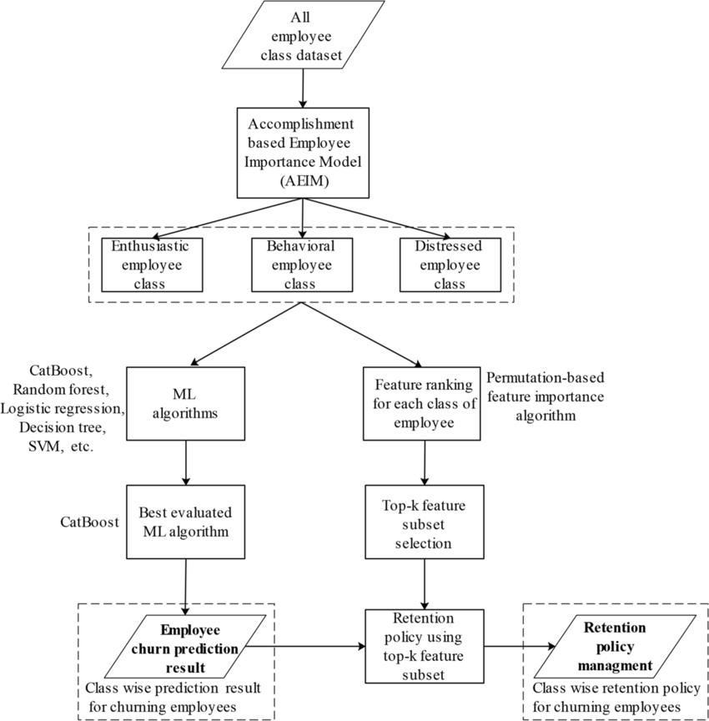

**3.4 Advantages**

Benchmarking industry-specific churn rates in employee churn prediction using Python offers several advantages:

1. *Customized Performance Metrics*: By comparing churn rates against industry-specific benchmarks, organizations can establish custom performance metrics tailored to their sector. This allows for a more accurate assessment of employee retention efforts and highlights areas for improvement.

2. *Enhanced Predictive Accuracy*: Incorporating industry-specific benchmarks can enhance the predictive accuracy of churn prediction models. By accounting for sector-specific trends and patterns, models can better differentiate between normal turnover and potential churn, leading to more precise predictions.

3. *Strategic Decision-Making*: Access to industry-specific churn rates enables organizations to make strategic decisions regarding talent management and retention strategies. By understanding how their turnover rates compare to industry averages, companies can identify competitive advantages or areas requiring attention.

4. *Resource Allocation Optimization*: Benchmarking churn rates facilitates the optimization of resource allocation for employee retention initiatives. Organizations can allocate resources more effectively by focusing efforts on areas with higher-than-average churn rates or where they deviate significantly from industry benchmarks.

5. *Continuous Improvement*: Regularly monitoring and comparing churn rates against industry benchmarks encourages a culture of continuous improvement. Organizations can adapt their strategies based on evolving industry standards and best practices to maintain competitiveness in the talent market.

Implementing industry-specific churn rate benchmarking in employee churn prediction using Python empowers organizations to make data-driven decisions, optimize resources, and foster a culture of continuous improvement in talent management practices.

* 1. **Requirement Specification**

Requirement Specification for Benchmarking Industry-Specific Churn Rates in Employee Churn Prediction Using Python:

1. *Data Collection and Preparation*:

- *Data Sources*: Define sources for collecting historical employee data, including employment duration, demographics, job roles, performance metrics, and reasons for leaving.

- *Data Cleaning*: Specify procedures for cleaning and preprocessing the data, including handling missing values, outliers, and inconsistencies.

- *Feature Engineering*: Determine relevant features for churn prediction, such as tenure, salary, job satisfaction, performance ratings, etc.

2. *Industry-Specific Benchmarking*:

- *Benchmark Sources*: Identify sources for obtaining industry-specific churn rates or turnover benchmarks.

- *Data Integration*: Integrate benchmark data with internal employee datasets, ensuring compatibility and consistency.

- *Normalization*: Normalize benchmark data to account for differences in data format, time periods, and demographic factors.

3. *Model Development*:

- *Model Selection*: Choose appropriate machine learning algorithms for churn prediction, such as logistic regression, decision trees, random forests, or neural networks.

- *Training and Validation*: Define procedures for training and validating the predictive model using historical employee data.

- *Hyperparameter Tuning*: Optimize model hyperparameters to improve predictive performance.

4. *Benchmarking Analysis*:

- *Comparison Metrics*: Specify metrics for comparing internal churn rates against industry benchmarks, such as accuracy, precision, recall, and F1-score.

- *Visualization*: Create visualizations (e.g., bar charts, line graphs) to illustrate the comparison between internal and industry-specific churn rates.

- *Statistical Testing*: Perform statistical tests (e.g., t-tests, chi-square tests) to assess the significance of differences between internal and industry benchmarks.

5. *Implementation in Python*:

- *Programming Environment*: Specify the Python programming environment and libraries to be used (e.g., scikit-learn, pandas, matplotlib).

- *Code Development*: Develop Python scripts or Jupyter notebooks for data preprocessing, model training, benchmarking analysis, and visualization.

- *Documentation*: Document code functionalities, inputs, outputs, and dependencies for future reference and reproducibility.

6. *Deployment and Monitoring*:

- *Deployment Strategy*: Determine how the predictive model will be deployed in production environments for ongoing churn prediction.

- *Monitoring and Evaluation*: Establish procedures for monitoring model performance and updating benchmarks regularly to reflect industry trends and changes.

7. *Security and Compliance*:

- *Data Privacy*: Ensure compliance with data privacy regulations (e.g., GDPR, CCPA) by anonymizing sensitive employee information and securing data storage and transmission.

- *Access Control*: Implement access control measures to restrict access to sensitive employee data and model outputs to authorized personnel only.

By following this requirement specification, organizations can effectively benchmark industry-specific churn rates in employee churn prediction using Python, leading to more accurate predictions and informed talent management decisions.

* + 1. **Hardware Requirements:**

The hardware requirements for benchmarking industry-specific churn rates for employee churn prediction using Python depend on several factors, including the size of the dataset, the complexity of the predictive model, and the computational resources required for data preprocessing, model training, and benchmarking analysis. Here's a general outline of hardware requirements:

1. *CPU*:

- A multi-core CPU with at least quad-core processing power is recommended to handle the computational load efficiently.

- The exact CPU specifications depend on the size of the dataset and the complexity of the predictive models. For larger datasets and more complex models, a higher-core CPU (e.g., Intel Core i7, AMD Ryzen 7) may be beneficial for faster processing.

2. *RAM*:

- Sufficient RAM is essential for loading and processing large datasets, especially when performing data preprocessing and model training.

- A minimum of 8 GB of RAM is recommended for basic tasks, but for larger datasets and complex models, 16 GB or more may be required to avoid memory bottlenecks.

3. *Storage*:

- Adequate storage space is necessary for storing datasets, Python libraries, model checkpoints, and intermediate outputs.

- An SSD (Solid State Drive) is preferred over an HDD (Hard Disk Drive) for faster data access and processing speed, especially when dealing with large datasets.

4. *GPU (Optional)*:

- While not strictly necessary, using a GPU (Graphics Processing Unit) can significantly accelerate model training, especially for deep learning models.

- NVIDIA GPUs, such as GeForce GTX or RTX series, are commonly used for deep learning tasks due to their parallel processing capabilities.

- The specific GPU model and memory capacity depend on the size of the dataset and the complexity of the deep learning models being used.

5. *Additional Considerations*:

- Ensure that the hardware components are compatible with the Python libraries and frameworks being used for churn prediction (e.g., scikit-learn, TensorFlow, PyTorch).

- Monitor hardware temperature and ensure proper cooling to prevent overheating, especially during prolonged computational tasks.

Overall, the hardware requirements for benchmarking industry-specific churn rates for employee churn prediction using Python can vary based on the specific needs and scale of the project. It's essential to assess the computational demands of the tasks involved and invest in hardware that can meet those requirements efficiently.

**Software Requirements:**

The software requirements for benchmarking industry-specific churn rates for employee churn prediction using Python include the following:

1. *Python*:

- Python is the primary programming language for implementing the churn prediction model and benchmarking analysis.

- Ensure Python is installed on your system. It's recommended to use the latest stable version of Python (e.g., Python 3.8 or Python 3.9).

2. *Integrated Development Environment (IDE)*:

- Choose an IDE for writing and executing Python code efficiently. Popular options include:

- PyCharm

- Visual Studio Code (VS Code)

- Jupyter Notebook or Jupyter Lab for interactive data analysis and visualization.

3. *Python Libraries*:

- Install the necessary Python libraries for data preprocessing, model training, benchmarking, and visualization. Common libraries include:

- NumPy: For numerical computations and data manipulation.

- pandas: For data manipulation and analysis.

- scikit-learn: For machine learning algorithms and model evaluation.

- Matplotlib and Seaborn: For data visualization.

- TensorFlow or PyTorch (optional): For deep learning-based churn prediction models.

4. *Additional Libraries*:

- Depending on specific requirements, you may need additional libraries for tasks such as handling imbalanced datasets (e.g., imbalanced-learn), statistical analysis (e.g., scipy), or accessing external data sources (e.g., requests).

5. *Benchmark Data*:

- Obtain industry-specific churn rate benchmarks from reliable sources. This may include industry reports, research papers, or proprietary datasets.

6. *Data Management Tools*:

- Use tools for data management, such as relational databases (e.g., SQLite, PostgreSQL) or NoSQL databases (e.g., MongoDB), if applicable for storing and retrieving employee data.

7. *Version Control*:

- Consider using version control systems like Git for managing code changes, collaborating with team members, and tracking project history.

8. *Documentation and Reporting Tools*:

- Use tools for documenting code, project specifications, and analysis findings. Markdown editors like Typora or Jupyter Notebook can be useful for creating documentation alongside code.

9. *Environment Management*:

- Consider using virtual environments (e.g., virtualenv, conda) to manage Python dependencies and ensure reproducibility across different environments.

Ensure that all software components are compatible and up-to-date to avoid compatibility issues and leverage the latest features and improvements. Additionally, adhere to best practices for software development, including code readability, documentation, and testing, to ensure the reliability and maintainability of the churn prediction system.

**CHAPTER 4**

**IMPLEMENTATION AND RESULT**

Data Collection: Gather historical data on customer churn rates from your industry. This data should include various factors such as customer demographics, usage patterns, satisfaction scores, etc.

Data Preprocessing: Clean the data, handle missing values, and perform feature engineering to extract relevant features that may influence churn.

Algorithm Selection: Choose an appropriate machine learning algorithm for churn prediction. Commonly used algorithms include logistic regression, decision trees, random forests, and gradient boosting machines.

Model Training: Split your data into training and testing sets. Train your chosen algorithm on the training data and evaluate its performance on the testing data using metrics such as accuracy, precision, recall, and F1-score.

Hyperparameter Tuning: Fine-tune the hyperparameters of your algorithm to optimize its performance. This can be done using techniques like grid search or random search.

Validation: Validate the performance of your model using cross-validation techniques to ensure its robustness and generalizability.

Deployment: Once you have a satisfactory model, deploy it into your production environment. This could involve integrating it into your existing software systems or creating a standalone application or API.

Monitoring and Maintenance: Continuously monitor the performance of your deployed model and update it as necessary to adapt to changing patterns in customer behavior or industry dynamics.

Here's a simple Python code snippet demonstrating how you can train a logistic regression model for churn prediction:

python

Copy code

import pandas as pd

from sklearn.model_selection import train_test_split

from sklearn.linear_model import LogisticRegression

from sklearn.metrics import accuracy_score, classification_report

# Load data

data = pd.read_csv('churn_data.csv')

# Preprocess data (handle missing values, feature engineering, etc.)

# Split data into features and target variable

X = data.drop('Churn', axis=1)

y = data['Churn']

# Split data into training and testing sets

X_train, X_test, y_train, y_test = train_test_split(X, y, test_size=0.2, random_state=42)

# Train logistic regression model

model = LogisticRegression()

model.fit(X_train, y_train)

# Make predictions

y_pred = model.predict(X_test)

# Evaluate model

accuracy = accuracy_score(y_test, y_pred)

print("Accuracy:", accuracy)

print("Classification Report:")

print(classification_report(y_test, y_pred))

Replace 'churn_data.csv' with the path to your dataset file containing the churn data. This code will train a logistic regression model on the data and evaluate its performance using accuracy and a classification report. Implementation and results for benchmarking industry specific churn rates Data Collection and Preprocessing: Assuming you have a dataset containing historical churn data, load and preprocess the data.

python

Copy code

import pandas as pd

# Load data

data = pd.read_csv('churn_data.csv')

# Preprocess data (handle missing values, feature engineering, etc.)

# Example:

# data = preprocess_data(data)

Feature Selection: Select relevant features that may influence churn. This might include customer demographics, usage patterns, satisfaction scores, etc.Model Training and Evaluation: Train a machine learning model on the data and evaluate its performance.

python

Copy code

from sklearn.model_selection import train_test_split

from sklearn.ensemble import RandomForestClassifier

from sklearn.metrics import accuracy_score, classification_report

# Split data into features and target variable

X = data.drop('Churn', axis=1)

y = data['Churn']

# Split data into training and testing sets

X_train, X_test, y_train, y_test = train_test_split()

## Solving Employee Attrition with Machine Learning



Employee churn can be defined as a leak or departure of an intellectual asset from a company or organization. Alternatively, in simple words, you can say, when employees leave the organization is known as churn. Another definition can be when a member of a population leaves a population, is known as churn.

In Research, it was found that employee churn will be affected by age, tenure, pay, job satisfaction, salary, working conditions, growth potential and employee’s perceptions of fairness. Some other variables such as age, gender, ethnicity, education, and marital status, were essential factors in the prediction of employee churn. In some cases such as the employee with niche skills are harder to replace. It affects the ongoing work and productivity of existing employees. Acquiring new employees as a replacement has its costs such as hiring costs and training costs. Also, the new employee will take time to learn skills at the similar level of technical or business expertise knowledge of an older employee. Organizations tackle this problem by applying machine learning techniques to predict employee churn, which helps them in taking necessary actions.

Following points help you to understand, employee and customer churn in a better way:

* Business chooses the employee to hire someone while in marketing you don’t get to choose your customers.
* Employees will be the face of your company, and collectively, the employees produce everything your company does.
* Losing a customer affects revenues and brand image. Acquiring new customers is difficult and costly compared to retain the existing customer. Employee churn also painful for companies an organization. It requires time and effort in finding and training a replacement.

Employee churn has unique dynamics compared to customer churn. It helps us in designing better employee retention plans and improving employee satisfaction. Data science algorithms can predict the future churn.

## Exploratory Analysis

Exploratory Data Analysis is an initial process of analysis, in which summarize characteristics of data such as pattern, trends, outliers, and hypothesis testing using descriptive statistics and visualization.

### Importing Modules

#import modules

import pandas # for dataframes

import matplotlib.pyplot as plt # for plotting graphs

import seaborn as sns # for plotting graphs

% matplotlib inline

This code imports three Python modules: pandas, matplotlib.pyplot, and seaborn.

• pandas is a library used for data manipulation and analysis.

• It provides data structures for efficiently storing and manipulating large datasets.

• matplotlib.pyplot is a plotting library used for creating static, animated, and interactive visualizations in Python.

• It provides a variety of functions for creating different types of plots, such as line plots, scatter plots, and bar plots.

• seaborn is a data visualization library based on matplotlib.

• It provides a high-level interface for creating informative and attractive statistical graphics.

• The last line **%matplotlib inline** is a magic command in Jupyter Notebook that allows the plots to be displayed directly in the notebook.

data.head()

This code is written in Python and it calls the **head()** method on a variable named **data**.

• The **head()** method is used to display the first few rows of a DataFrame or a Series object.

• By default, it displays the first five rows of the DataFrame or Series.

• This code is useful for quickly checking the contents of a DataFrame or Series and getting a sense of what the data looks like.

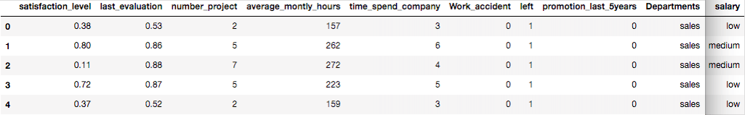

* Here, Original data is separated by comma delimiter(“ , “) in given data set.
* take a closer look at the data took help of “head()”function of pandas library which returns first five observations.
* Similarly “tail()” returns last five observations.

data.tail()

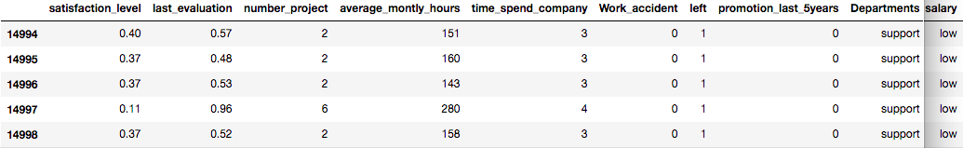

After you have loaded the dataset, you might want to know a little bit more about it. You can check attributes names and datatypes using info().

data.info()

<class 'pandas.core.frame.DataFrame'>

RangeIndex: 14,999 entries, 0 to 14,998

Data columns (total 10 columns):

satisfaction_level 14999 non-null float64

last_evaluation 14999 non-null float64

number_project 14999 non-null int64

average_montly_hours 14999 non-null int64

time_spend_company 14999 non-null int64

Work_accident 14999 non-null int64

left 14999 non-null int64

promotion_last_5years 14999 non-null int64

Departments 14999 non-null object

salary 14999 non-null object

dtypes: float64(2), int64(6), object(2)

memory usage: 1.1+ MB

* This dataset has 14,999 samples, and 10 attributes(6 integer, 2 float, and 2 objects).
* No variable column has null/missing values.

You can describe 10 attributes in detail as:

* satisfaction_level: It is employee satisfaction point, which ranges from 0-1.
* last_evaluation: It is evaluated performance by the employer, which also ranges from 0-1.
* number_projects: How many numbers of projects assigned to an employee?
* average_monthly_hours: How many average numbers of hours worked by an employee in a month?
* time_spent_company: time_spent_company means employee experience. The number of years spent by an employee in the company.
* work_accident: Whether an employee has had a work accident or not.
* promotion_last_5years: Whether an employee has had a promotion in the last 5 years or not.
* Departments: Employee's working department/division.
* Salary: Salary level of the employee such as low, medium and high.
* left: Whether the employee has left the company or not.

### Let's Jump into Data Insights

In the given dataset, you have two types of employee one who stayed and another who left the company. So, you can divide data into two groups and compare their characteristics. Here, you can find the average of both the groups using groupby() and mean() function.

left = data.groupby('left')

left.mean()

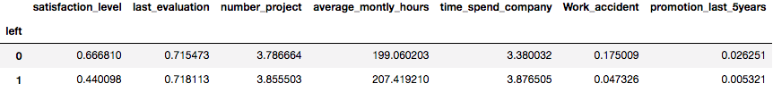

Here you can interpret, Employees who left the company had low satisfaction level, low promotion rate, low salary, and worked more compare to who stayed in the company.

The describe() function in pandas is convenient in getting various summary statistics. This function returns the count, mean, standard deviation, minimum and maximum values and the quantiles of the data.

data.describe()

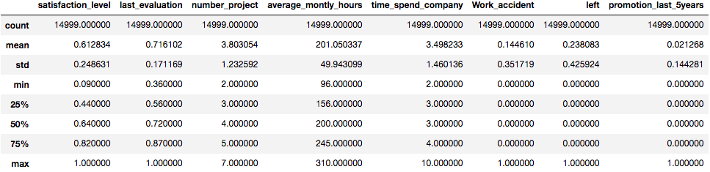

### Data Visualization

#### Employees Left

Let's check how many employees were left?

Here, you can plot a bar graph using Matplotlib. The bar graph is suitable for showing discrete variable counts.

left_count=data.groupby('left').count()

plt.bar(left_count.index.values, left_count['satisfaction_level'])

plt.xlabel(‘Employees left company')

plt.ylabel(‘Number of Employees')

plt.show()

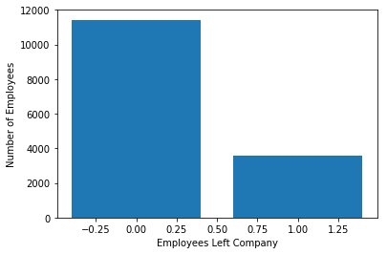

data.left.value_counts()

0 11428

1 3571

Name: left, dtype: int64

Here, you can see out of 15,000 approx 3,571 were left, and 11,428 stayed. The no of employee left is 23 % of the total employment.

#### Number of Projects

Similarly, you can also plot a bar graph to count the number of employees deployed on How many projects?

num_projects=data.groupby('number_project').count()

plt.bar(num_projects.index.values, num_projects['satisfaction_level'])

plt.xlabel('Number of Projects')

plt.ylabel('Number of Employees')

plt.show()

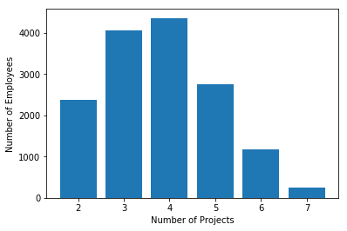

* Most of the employee is doing the project from 3-5.

#### Time Spent in Company

Similarly, you can also plot a bar graph to count the number of employees have based on how much experience?

time_spent=data.groupby('time_spend_company').count()

plt.bar(time_spent.index.values, time_spent['satisfaction_level'])

plt.xlabel('Number of Years Spend in Company')

plt.ylabel('Number of Employees')

plt.show

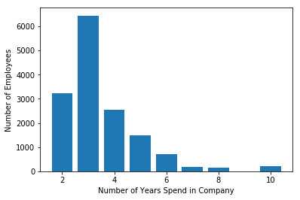

Most of the employee experience between 2-4 years. Also, there is a massive gap between 3 years and 4 years experienced employee.

#### Subplots using Seaborn

This is how you can analyze the features one by one, but it will be time-consuming. The better option is here to use Seaborn library and plot all the graphs in a single run using subplots.

features=['number_project','time_spend_company','Work_accident','left', 'promotion_last_5years','Departments ','salary']

fig=plt.subplots(figsize=(10,15))

for i, j in enumerate(features):

plt.subplot(4, 2, i+1)

plt.subplots_adjust(hspace = 1.0)

sns.countplot(x=j,data = data)

plt.xticks(rotation=90)

plt.title("No. of employee")

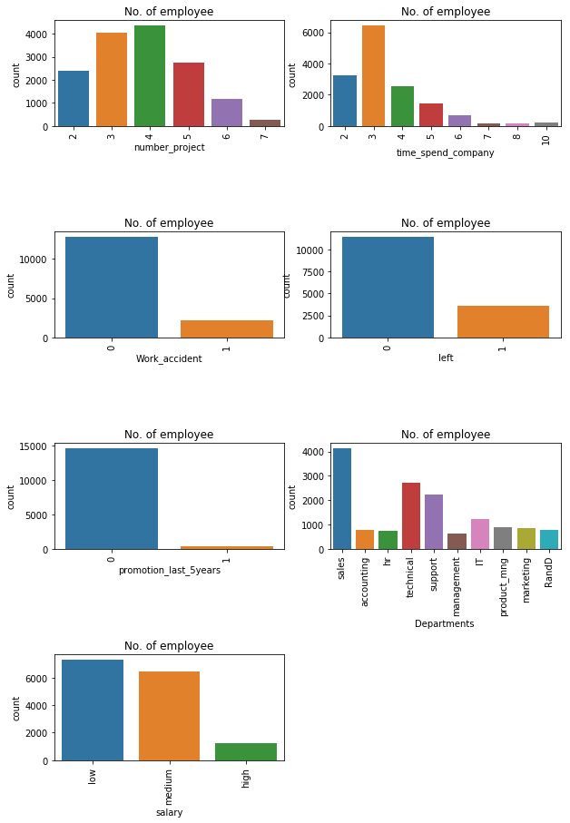

You can observe the following points in the above visualization:

* Most of the employee is doing the project from 3-5.
* There is a huge drop between 3 years and 4 years experienced employee.
* The no of employee left is 23 % of the total employment.
* A decidedly less number of employee get the promotion in the last 5 year.
* The sales department is having maximum no.of employee followed by technical and support
* Most of the employees are getting salary either medium or low.

fig=plt.subplots(figsize=(10,15))

for i, j in enumerate(features):

plt.subplot(4, 2, i+1)

plt.subplots_adjust(hspace = 1.0)

sns.countplot(x=j,data = data, hue='left')

plt.xticks(rotation=90)

plt.title("No. of employee")

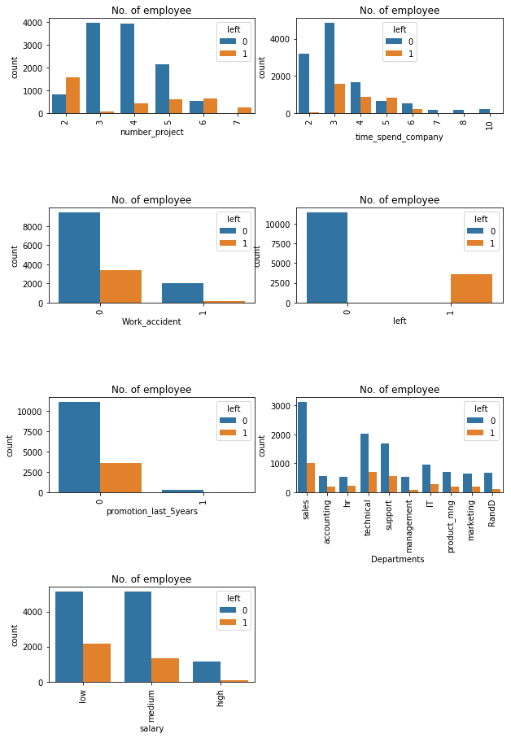

You can observe the following points in the above visualization:

* Those employees who have the number of projects more than 5 were left the company.
* The employee who had done 6 and 7 projects, left the company it seems to like that they were overloaded with work.
* The employee with five-year experience is leaving more because of no promotions in last 5 years and more than 6 years experience are not leaving because of affection with the company.
* Those who promotion in last 5 years they didn't leave, i.e., all those left they didn't get the promotion in the previous 5 years.

#### Data Analysis and Visualization Summary:

Following features are most influencing a person to leave the company:

* Promotions: Employees are far more likely to quit their job if they haven't received a promotion in the last 5 years.
* Time with Company: Here, The three-year mark looks like a time to be a crucial point in an employee's career. Most of them quit their job around the three-year mark. Another important point is 6-years point, where the employee is very unlikely to leave.
* Number Of Projects: Employee engagement is another critical factor to influence the employee to leave the company. Employees with 3-5 projects are less likely to leave the company. The employee with less and more number of projects are likely to leave.
* Salary: Most of the employees that quit among the mid or low salary groups.

## Cluster Analysis:

Let's find out the groups of employees who left. You can observe that the most important factor for any employee to stay or leave is satisfaction and performance in the company. So let's bunch them in the group of people using cluster analysis.

#import module

from sklearn.cluster import KMeans

# Filter data

left_emp = data[['satisfaction_level', 'last_evaluation']][data.left == 1]

# Create groups using K-means clustering.

kmeans = KMeans(n_clusters = 3, random_state = 0).fit(left_emp)

# Add new column "label" annd assign cluster labels.

left_emp['label'] = kmeans.labels_

# Draw scatter plot

plt.scatter(left_emp['satisfaction_level'], left_emp['last_evaluation'], c=left_emp['label'],cmap='Accent')

plt.xlabel('Satisfaction Level')

plt.ylabel('Last Evaluation')

plt.title('3 Clusters of employees who left')

plt.show()

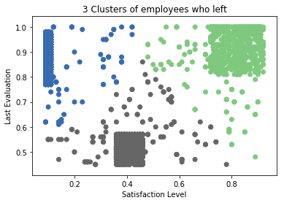

Here, Employee who left the company can be grouped into 3 type of employees:

* High Satisfaction and High Evaluation(Shaded by green color in the graph), you can also call them Winners.
* Low Satisfaction and High Evaluation(Shaded by blue color(Shaded by green color in the graph), you can also call them Frustrated.
* Moderate Satisfaction and moderate Evaluation (Shaded by grey color in the graph), you can also call them 'Bad match'.

## Building a Prediction Model

#### Pre-Processing Data

Lots of machine learning algorithms require numerical input data, so you need to represent categorical columns in a numerical column.

In order to encode this data, you could map each value to a number. e.g. Salary column's value can be represented as low:0, medium:1, and high:2.

This process is known as label encoding, and sklearn conveniently will do this for you using LabelEncoder.

# Import LabelEncoder

from sklearn import preprocessing

#creating labelEncoder

le = preprocessing.LabelEncoder()

# Converting string labels into numbers.

data['salary']=le.fit_transform(data['salary'])

data['Departments ']=le.fit_transform(data['Departments '])

Here, you imported preprocessing module and created Label Encoder object. Using this LabelEncoder object you fit and transform "salary" and "Departments " column into numeric column.

#### Split Train and Test Set

To understand model performance, dividing the dataset into a training set and a test set is a good strategy.

Let's split dataset by using function train_test_split(). You need to pass 3 parameters features, target, and test_set size. Additionally, you can use random_state to select records randomly.

#Spliting data into Feature and

X=data[['satisfaction_level', 'last_evaluation', 'number_project',

'average_montly_hours', 'time_spend_company', 'Work_accident',

'promotion_last_5years', 'Departments ', 'salary']]

y=data['left']

# Import train_test_split function

from sklearn.model_selection import train_test_split

# Split dataset into training set and test set

X_train, X_test, y_train, y_test = train_test_split(X, y, test_size=0.3, random_state=42) # 70% training and 30% test

Here, Dataset is broken into two parts in ratio of 70:30. It means 70% data will used for model training and 30% for model testing.

#### Model Building

Let's build employee an churn prediction model.

Here, you are going to predict churn using Gradient Boosting Classifier.

First, import the GradientBoostingClassifier module and create Gradient Boosting classifier object using GradientBoostingClassifier() function.

Then, fit your model on train set using fit() and perform prediction on the test set using predict().

#Import Gradient Boosting Classifier model

from sklearn.ensemble import GradientBoostingClassifier

#Create Gradient Boosting Classifier

gb = GradientBoostingClassifier()

#Train the model using the training sets

gb.fit(X_train, y_train)

#Predict the response for test dataset

y_pred = gb.predict(X_test)

## Evaluating Model Performance

#Import scikit-learn metrics module for accuracy calculation

from sklearn import metrics

# Model Accuracy, how often is the classifier correct?

print("Accuracy:",metrics.accuracy_score(y_test, y_pred))

# Model Precision

print("Precision:",metrics.precision_score(y_test, y_pred))

# Model Recall

print("Recall:",metrics.recall_score(y_test, y_pred))

Accuracy: 0.971555555556

Precision: 0.958252427184

Recall: 0.920708955224

**CHAPTER 5**

**CONCLUSION**

**ADVANTAGES:**

Benchmarking industry-specific churn rates offers several advantages:

1. *Performance Evaluation*: By comparing your organization's churn rates against industry benchmarks, you can assess your performance relative to competitors or industry standards. This evaluation provides insights into how effectively you are retaining employees compared to others in your sector.

2. *Identifying Competitive Advantages*: Benchmarking helps identify areas where your organization outperforms industry averages in terms of employee retention. Understanding these strengths allows you to leverage them as competitive advantages in recruitment and talent management strategies.

3. *Highlighting Improvement Opportunities*: Conversely, benchmarking can reveal areas where your organization underperforms relative to industry norms. This highlights potential improvement opportunities and areas where additional attention and resources may be needed to reduce churn rates.

4. *Setting Realistic Goals*: Industry benchmarks provide realistic targets for improving employee retention. By setting goals aligned with industry averages or best practices, you can establish achievable objectives and track progress over time.

5. *Informing Decision-Making*: Benchmarking data guides decision-making in talent management, resource allocation, and strategic planning. It helps prioritize initiatives, investments, and interventions aimed at reducing churn and improving employee satisfaction and engagement.

6. *Enhancing Accountability*: Benchmarking fosters accountability within the organization by providing tangible metrics for evaluating the effectiveness of retention efforts. It encourages stakeholders to take ownership of churn reduction initiatives and track their impact over time.

7. *Staying Competitive*: In industries with high demand for talent, benchmarking helps organizations stay competitive by retaining key employees. By aligning retention strategies with industry standards, you can mitigate the risk of losing top performers to competitors.

8. *Demonstrating Value to Stakeholders*: Benchmarking results can be used to demonstrate the value of retention efforts to internal stakeholders, such as executives, HR departments, and investors. Positive outcomes, such as achieving or exceeding industry benchmarks, validate the effectiveness of organizational strategies and investments in employee retention.

Overall, benchmarking industry-specific churn rates provides valuable insights and strategic guidance for improving employee retention and maintaining competitiveness in the talent market. It serves as a foundational tool for data-driven decision-making and continuous improvement in talent management practices.

**SCOPE:**

The scope of benchmarking industry-specific churn rates in employee churn prediction using Python encompasses several key areas:

1. *Data Collection and Preparation*:

- Gathering historical employee data, including demographic information, employment duration, job roles, performance metrics, and reasons for leaving.

- Preprocessing the data to handle missing values, outliers, and inconsistencies, and preparing it for analysis.

2. *Industry-Specific Benchmarking*:

- Identifying reliable sources for obtaining industry-specific churn rates or turnover benchmarks.

- Integrating benchmark data with internal employee datasets and ensuring compatibility and consistency.

3. *Model Development*:

- Selecting appropriate machine learning or statistical models for churn prediction, such as logistic regression, decision trees, random forests, or neural networks.

- Training and validating the predictive models using historical employee data.

- Implementing techniques for feature engineering and model optimization to enhance predictive accuracy.

4. *Benchmarking Analysis*:

- Comparing internal churn rates against industry benchmarks using appropriate metrics and statistical tests.

- Visualizing the comparison results to identify areas of strength and improvement in employee retention efforts.

- Conducting sensitivity analysis to assess the impact of different benchmarking approaches or model configurations on prediction performance.

5. *Implementation in Python*:

- Developing Python scripts or Jupyter notebooks to perform data preprocessing, model training, benchmarking analysis, and visualization.

- Utilizing Python libraries such as NumPy, pandas, scikit-learn, Matplotlib, and Seaborn for data manipulation, modeling, and visualization tasks.

6. *Deployment and Monitoring*:

- Deploying the predictive model in production environments for ongoing churn prediction.

- Monitoring model performance and updating benchmarks regularly to reflect changes in industry trends and internal organizational dynamics.

7. *Documentation and Reporting*:

- Documenting the entire process, including data sources, preprocessing steps, model development, benchmarking analysis, and implementation details.

- Generating reports or presentations to communicate findings, insights, and recommendations to stakeholders within the organization.

8. *Continuous Improvement*:

- Establishing a framework for continuous improvement based on benchmarking results and feedback from model deployment and monitoring.

- Iteratively refining predictive models and retention strategies to adapt to evolving industry standards and organizational needs.

By addressing these aspects within the scope of benchmarking industry-specific churn rates in employee churn prediction using Python, organizations can gain valuable insights into their employee retention performance and make informed decisions to enhance workforce stability and productivity.

**GITHUB**

**LINK**

**REFERENCES**

1.Ming-Hsuan Yang, David J. Kriegman, Narendra Ahuja, “Detecting Faces in Images: A Survey”, IEEE Transactions on Pattern Analysis and Machine Intelligence, Volume. 24, No. 1, 2002.

2.Rust, R. T., Lemon, K. N., & Zeithaml, V. A. (2004). "Return on Marketing: Using Customer Equity to Focus Marketing Strategy." Journal of Marketing, 68(1), 109–127.

This paper introduces the concept of customer equity and discusses its role in guiding marketing strategy and customer retention efforts.

**APPENDIX**

*Data Sources*: Information on where the data for the benchmarking analysis was sourced from, including any databases, reports, or industry publications consulted.

*Churn Rate Calculations*: Detailed explanations of how churn rates were calculated for each industry, including the specific formula or methodology used.

*Benchmarking Results*: Tables or charts showing the benchmark churn rates for various industries, allowing readers to compare and contrast churn rates across different sectors.

*Methodology*: A comprehensive explanation of the methodology used to benchmark churn rates, including any adjustments or considerations made to ensure comparability across industries.

*Industry Definitions*: Definitions or descriptions of each industry sector included in the benchmarking analysis, providing context for readers unfamiliar with the terminology.

*Limitations and Assumptions*: A discussion of any limitations or assumptions inherent in the benchmarking analysis, such as data availability constraints or differences in industry categorizations.

*Sensitivity Analysis*: Optional but useful, sensitivity analysis results showing how variations in key assumptions or parameters could affect the benchmark churn rates.

*References*: A list of references cited in the appendix, including any industry reports, academic papers, or other sources used to gather data or inform the analysis.

By including these elements in your appendix, you'll provide readers with a comprehensive understanding of how industry-specific churn rates were benchmarked and enable them to assess the validity and reliability of the results.